Month 2: Week 3 Report
• Identify false positives in logs
• Suppress noisy rules, fine-tune alerts
• Adjust rules for better precision
1: Identify False Positives in Snort Logs
. What is a False Positive?
An alert triggered by Snort for benign / non-malicious traffic.
A false positive occurs when Snort generates an alert for normal, non-malicious traffic. Identifying false positives is important to improve the accuracy of your NIDS.
Where to find logs:
• Snort console output (-A console)
• /var/log/snort/alert or unified2 logs
Steps to identify false positives:
1. Review Snort alerts and compare them with expected traffic patterns.
2. Confirm whether the source/destination IPs belong to trusted systems.
3. Match alerts with actual system activity to verify legitimacy
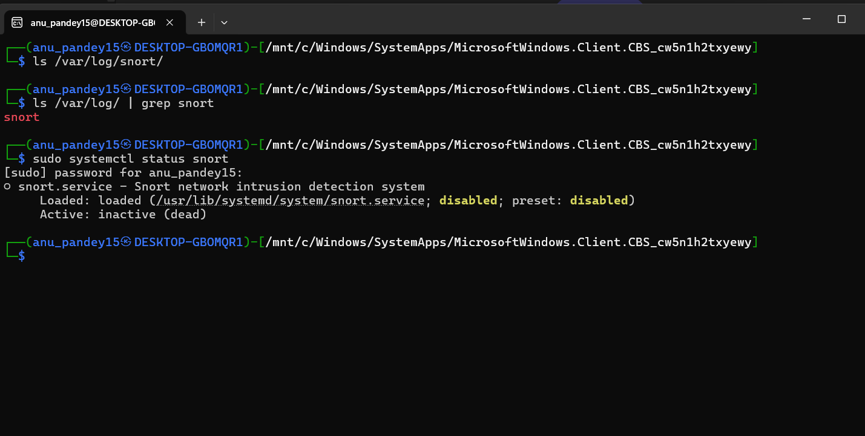

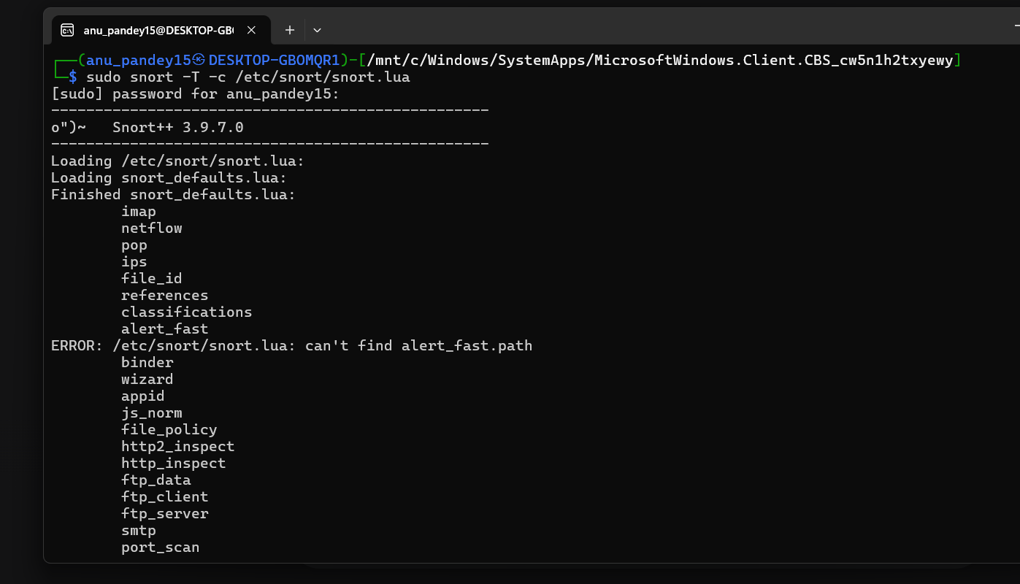
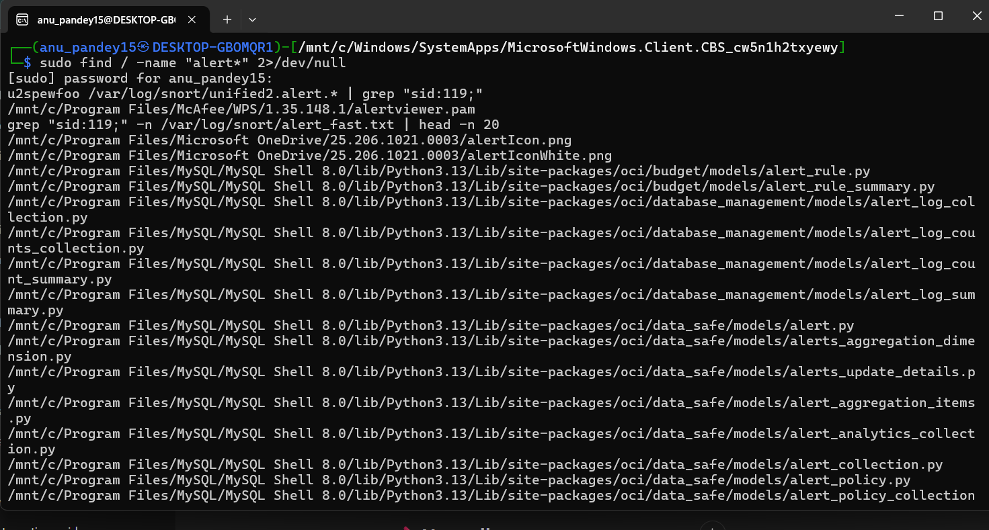

2) Suppress noisy rules & fine-tune alerts
Some Snort rules may generate excessive alerts. Suppression helps reduce noise without disabling important rules.
Methods to suppress or fine-tune:
• Use 'suppress' keyword in threshold.conf
• Modify rule conditions such as IPs, ports, or protocol
• Apply thresholds to reduce repeated alerts
Example suppression entry:
suppress gen_id 1, sig_id 100001, track by_src
.
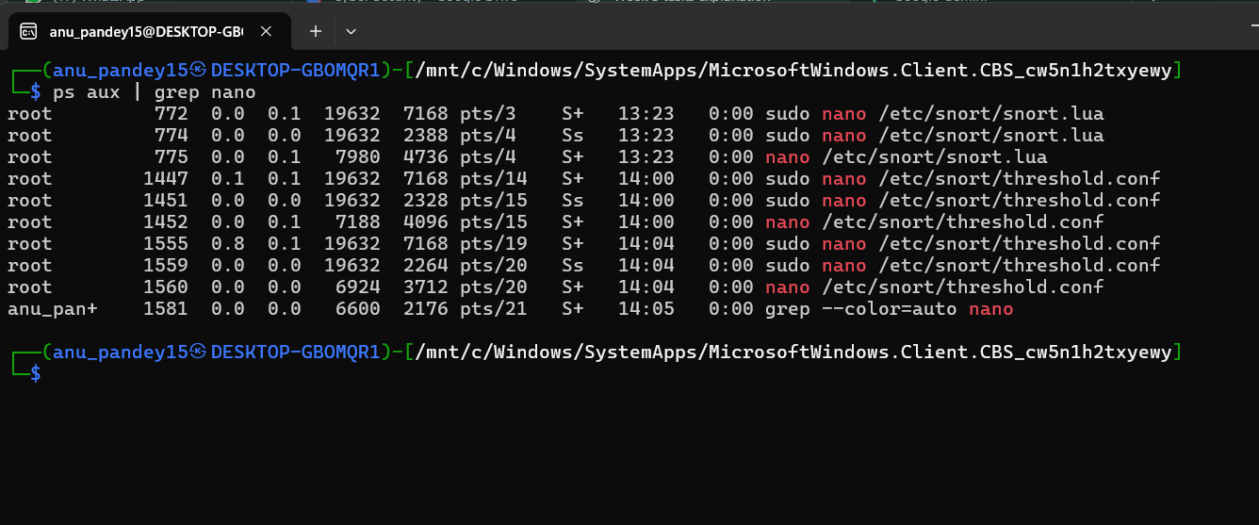

3) Adjust Rules for Better Precision
Fine-tuning rules helps ensure Snort detects only malicious activity. Adjustments may include modifying content fields, adding flow direction, or updating metadata.
Steps for precision tuning:
1. Add 'flow:to_server,established' to ensure correct traffic direction.
2. Refine 'content' or 'pcre' to match specific attack patterns.
3. Narrow source/destination IP ranges if necessary.
